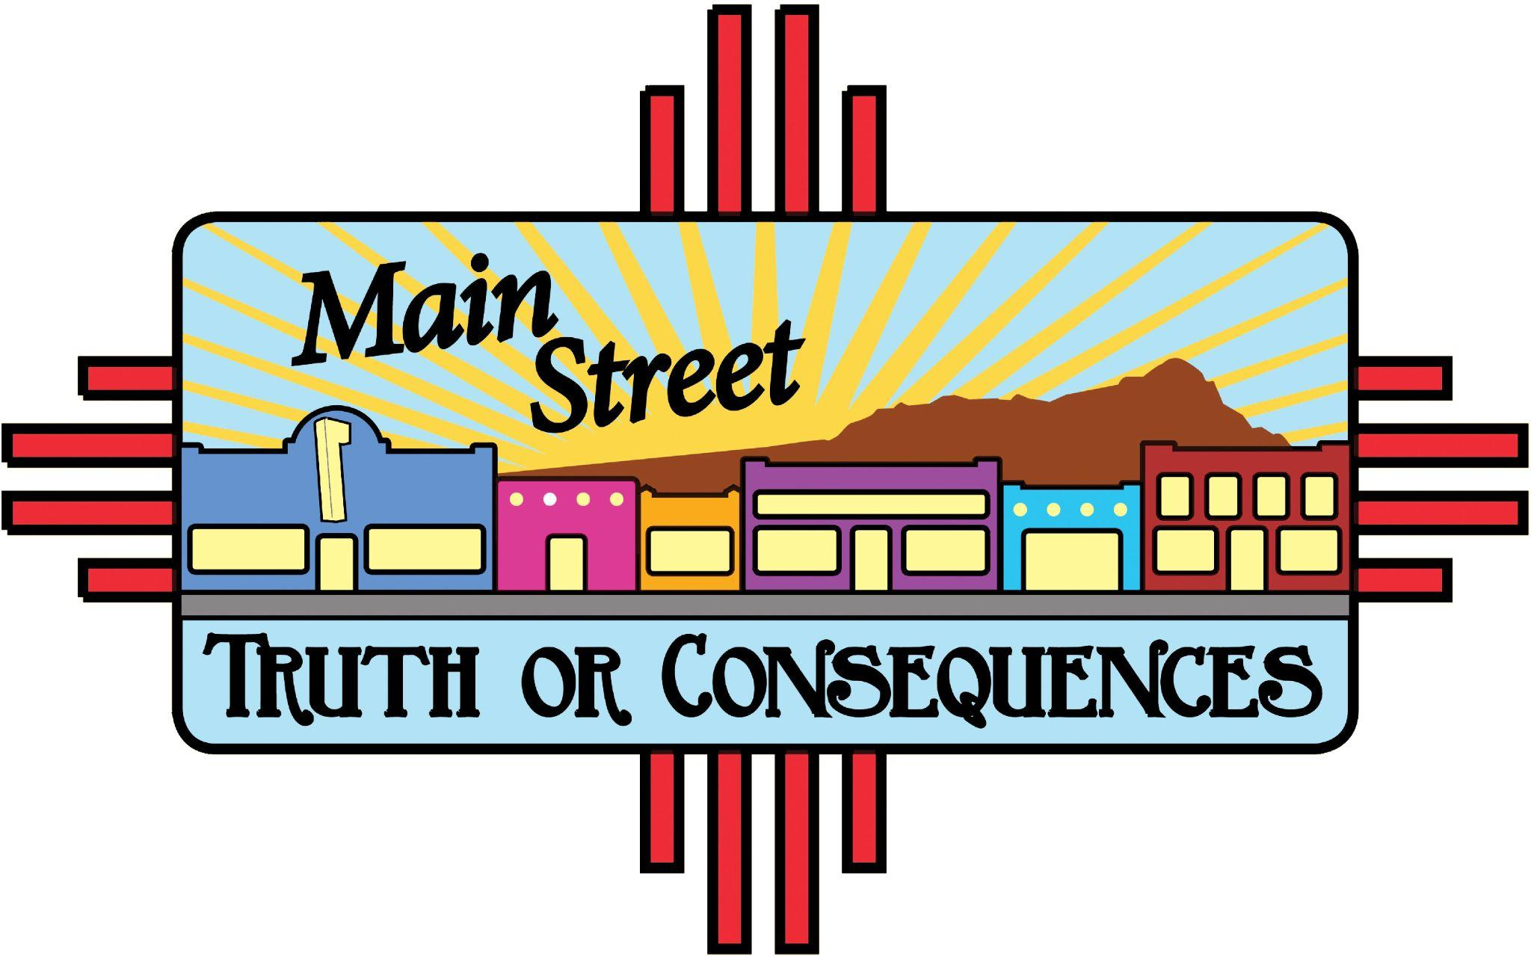 

***T or C Curb Appeal* Application**

**Project details:**

T or C Curb Appeal is a **MainStreet T or C** project, partially funded by a grant from the New Mexico Resiliency Alliance with additional funding contributions from local organizations and individuals.

Any **business owner or building owner in the MainStreet district** may apply for a microgrant to carry out an **exterior, street-facing improvement project**. The proposed project should make a visible and substantial improvement in the appearance of the exterior of the business/building. Improvements must be visible from the sidewalk/street and may include upgrades such as **paint, signage, lighting, landscaping**, or any other building or site elements that would help enhance the appearance of downtown Truth or Consequences.

Grants are available from $200 to $1,200.

The applicant must provide a **1:2 cash match** for the grant (for example, if your total project budget is $600, you should apply for $400 and must contribute an additional $200). A detailed budget must be submitted with the application.

If the project requires permitting, you are responsible for contacting the City of T or C to obtain all necessary permits.

If the project involves changes to the building itself, the legal owner of the property must provide permission by signing this application.

If you are awarded a grant, our New Mexico MainStreet design professional is available to assist with renderings and design guidance, if desired.

**Timeline:**

The application deadline is **September 1, 2025** at 11:59 pm.

Grants will be awarded by **September 15, 2025**.

All projects must be completed by **November 30, 2025**.

If your project has not begun by November 1, we will ask you to submit a project timeline with details of how you will complete the project by November 30.

Grantees will be selected by a committee of local representatives who will evaluate applications based on visual impact, benefit to the business, contribution to the district, and readiness to complete the project within the grant timeline.

**Application:**

Note:Grantees will be required to sign a contract prior to receiving funding. The contract is provided at the end of this application for your review.

Complete all sections of this application in full, and submit by 11:59 pm on September 1, 2025 by one of these methods:

Email to: **director@torcmainstreet.org**

Mail to: **MainStreet Truth or Consequences, PO Box 1602, T or C, NM 87901**  (if submitting by mail, allow several days for delivery)

In person: drop off at the MainStreet office, 308 S. Pershing

**Applicant Information:**

| Name: | Business Name: |
| --- | --- |
| Email: | Phone: |
| Mailing Address: | |
| Project Address: | |

**Property Owner Information** (if different from Applicant)**:**

| Name: | Phone: |
| --- | --- |
| Email: | |
| Mailing Address: | |

Requested grant amount: __________________________________________

Your additional contribution amount (must be at least a 1:2 match): ______________________

Description of improvements: ______________________________________________

______________________________________________________________________

______________________________________________________________________

______________________________________________________________________

Detailed project budget: (you may attach a separate document if desired):

NOTE: Grant funds may be used for materials and basic consumable supplies directly related to the improvement project (e.g., paint, brushes, rollers, planters, plants, hardware). However, funds **may not be used to purchase tools or equipment**, including power tools, ladders, or other reusable items. Basic disposable supplies such as paintbrushes or gloves are allowed.

______________________________________________________________________

______________________________________________________________________

______________________________________________________________________

______________________________________________________________________

______________________________________________________________________

______________________________________________________________________

What will this project accomplish? How will it benefit your business and/or improve the “curb appeal” of downtown T or C?:

______________________________________________________________________

______________________________________________________________________

______________________________________________________________________

______________________________________________________________________

______________________________________________________________________

______________________________________________________________________

I acknowledge the project timeline, have reviewed the contract, and hereby submit my application for a microgrant for an exterior, street-facing improvement in downtown T or C.

Applicant signature: _____________________________________________________

Date: _________________________________

Property owner signature:_________________________________________________

(required if the project involves any physical changes to the building)

Date: _________________________________

**Contract (please review prior to applying)**

*If selected for a microgrant, we will ask you to sign this contract prior to receiving funding).*

**T or C Curb Appeal Microgrant Agreement** *MainStreet Truth or Consequences*

This agreement is made and entered into on this ___ day of __________, 2025, by and between **MainStreet Truth or Consequences**, hereinafter referred to as “MainStreet T or C,” and the grant recipient, _____________________________________, hereinafter referred to as the “Grantee.”

### **1. Purpose**

The purpose of this agreement is to outline the responsibilities of the Grantee in accepting funds awarded through the *T or C Curb Appeal* microgrant program. These funds are intended to support façade and streetside improvements that contribute to the beautification and revitalization of downtown Truth or Consequences.

### **2. Grant Amount**

The total microgrant award for the approved project is:  
 **$__________**

The Grantee’s cash contribution to this project is:

**$__________**

Funds will be distributed up-front after the execution of this contract.

The Grantee must **submit copies of receipts** to MainStreet T or C accounting for use of the funds plus the cash match, no later than **December 5, 2025.**

### **3. Grant Requirements**

By accepting this microgrant, the Grantee agrees to the following terms:

**a. Project Deadline** The improvement project must be completed **no later than November 30, 2025**. Projects not completed by this deadline may result in forfeiture or return of funds.

Projects not begun by November 1will require submission of a timeline that details how the project will be completed by November 30.

**b. Photo Documentation** The Grantee agrees to provide **before and after photos** of the improvement project. Photos must clearly show the façade or sidewalk area where the work has been completed. Final documentation must be submitted no later than **December 5, 2025**.

**c. Social Media and MainStreet T or C Acknowledgement**

The Grantee agrees to make a minimum of 2 social media posts about their project (one showcasing the work in progress, one with the completed project) and acknowledge/tag MainStreet T or C.

If the Grantee does not use social media, an alternative means of promoting the project will be arranged.

Further, the Grantee agrees to post a MainStreet T or C window cling or sticker on or near the project.

**d. Maintaining Upgrades**

The Grantee agrees to maintain the funded improvements and not remove or significantly alter the upgrades for a minimum period of one (1) year from the date of project completion. Any changes to the improvements within this period must be submitted in writing and approved by MainStreet T or C.

**e. Maintenance Commitment** To support the long-term goals of the program, the Grantee agrees to **maintain their improved storefront or façade area** by performing the following tasks at least once per month for a period of **one year** following project completion:

* Washing or wiping down front-facing windows
* Sweeping or otherwise cleaning the sidewalk and entry area

### **4. Use of Funds**

Funds must be used for the purposes outlined in the Grantee’s approved application, such as exterior paint, signage, lighting, planters, seating, or other visual improvements that enhance the building’s curb appeal. Any substantial changes to the approved project must be submitted in writing and approved by MainStreet T or C.

### **5. Publicity**

Grantee agrees that MainStreet T or C may use project photos and business names for promotional purposes related to the *T or C Curb Appeal* program and other community revitalization efforts.

Grantee further agrees to acknowledge the funding from MainStreet T or C in any social media posts or other public communications about the improvements.

### **6. Non-Compliance**

Failure to comply with the terms outlined in this agreement may result in ineligibility for future grant opportunities or a request to return disbursed funds.

### **7. Acceptance**

**Business Name:** ___________________________________________

**Project Address:** __________________________________________

**Grantee Name (Printed):** ___________________________________

**Signature:** __________________________________________ Date: _______________

**MainStreet T or C Representative:**

Name: ___________________________________

Signature: __________________________________________ Date: _______________